Link GitHub : https://github.com/HitoKawiswara/LAB_WEEK_13

Commit 1 :
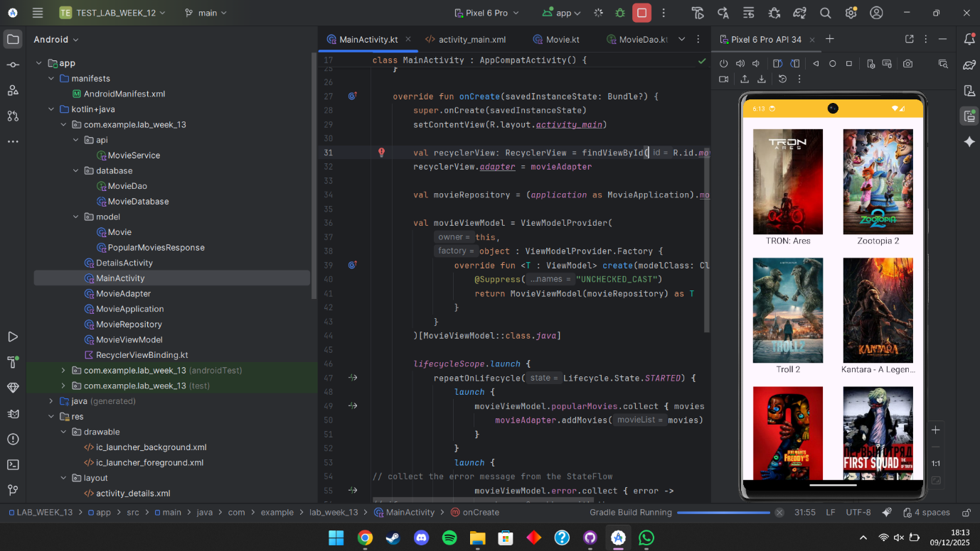
Commit 2 :
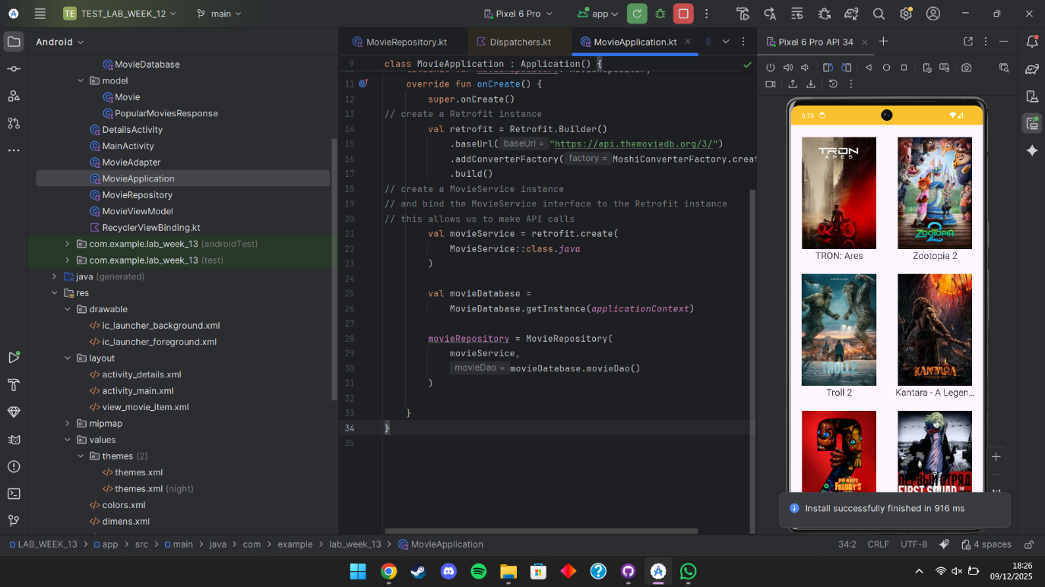Commit 3 :
